(Name of the project)
Coordinator:
Members:
1. Significance of the project
(Why we do this project? What is the possible application in the future?)

2. Target of the project
(What is the target of the project that we plan to achieve? Need to include functions and performance indexes)

3. System design
Currently there are three demos in our testbed: collision avoidance, traffic light control and vehicle tracking.

4. Duty assignment
(A figure describing each member’s duty and relationships, progress planned)

5. Hardware design
(Hardware architecture, introduction of key components/chips and interactions)

6. Software design
For all the three demos, collision avoidance, traffic light control and monitoring, there are three major components:
- The embedded program running on individual vehicles
- The embedded program running on traffic light controller
- The Java program for intercept the vehicle messages and track them
The functional blocks for the embedded programs are shown in the figure below:
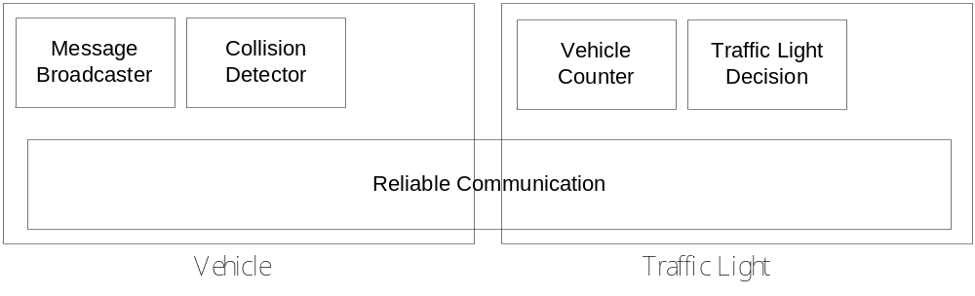
In the bottom layer, there is a module for reliable communication between vehicle and traffic light. Since wireless communication is unreliable, deploying this module can ensure that the demos will run smoothly. The mechanism for the reliable communication can be illustrated in the flow chart below:
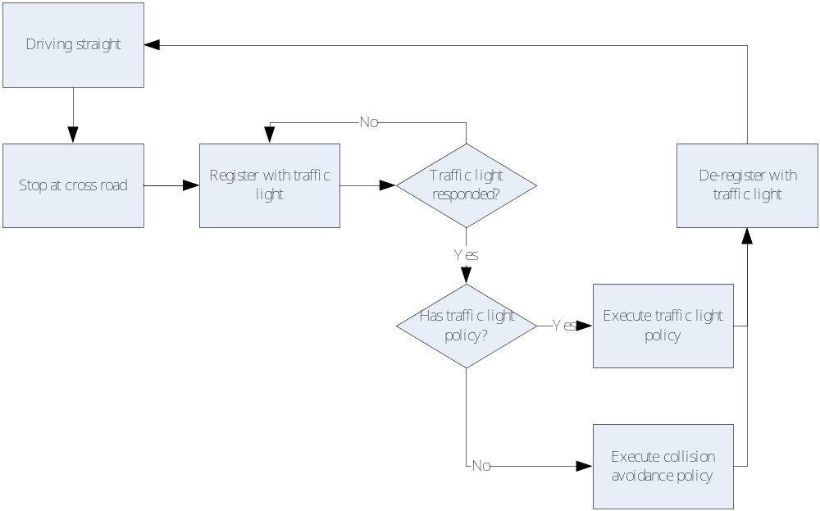
Since each vehicle needs to reliably communicate with others at the cross road and the vehicles at a particular cross road change over the time, we use a registration mechanism so that the traffic light for each cross road can keep track of the vehicles nearby to facilitate reliable communication.
Both traffic light policy and collision avoidance is enforced by the traffic light. The traffic light policy works as follows:
- When a vehicle first successfully registered with a traffic light, the traffic light will acknowledge it with its current light color.
- In case the light color is red, the traffic light controller will inform the vehicle again when the color turns green.
- Internally, the traffic light controller changes color for each traffic light periodically. However, in case when one road has vehicles and another has none, the controller will extend the green light duration for the road with vehicles
The collision avoidance policy works as follows:
- After a vehicle register with a traffic light, it will be put into a queue.
- The traffic light then informs each vehicle to start in a FIFO fashion.
7. Hardware implementation
(SCH file, PCB file, status description on current status of the file or hardware debugging)

8. Software development
(Status description of each module in the flowchart)

9. System testing
(Photos of the experimental scenario, description of the scenario and parameters setting in the system and conditions of the experiment, results recording and analysis, conclusions with drawbacks of the system)

10. Appendix
(All the codes)

